Activity1 – Test case genration

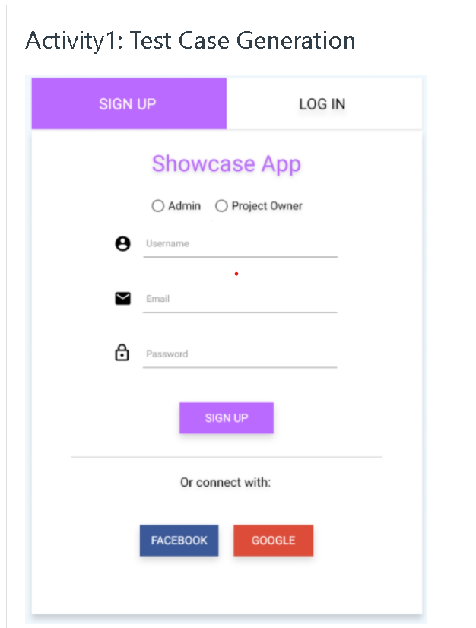

Test Case’s for webpage

- Validating if the webpage is clickable or not.
- validating input feilds with valid dataset.
- Validating with password with only character’s
like -“easypassword” (password must include alpha numeric combination including symbol’s)
- validating functionality of radio button’s
like “Admin” or “Project Owner”
- validating company logo’s colour scheme.
- validating alignment of webpage.
- Validating alignment of Input feilds,Radio button’s and password
- validating or connect with features by clicking FACEBOOK/GOOGLE
- validating Email with invalid format
like “abc1111111111” without using ‘@’ and orgnisation name like (@gmail.com)
- validating functionality of SIGN UP button “working or not by clicking “
- validating functionality of SIGNUP button with empty foam submission.
- Validating GUI of webpage across various devices
- validating GUI of webpage if webpage is clear or not
like all icons are visible or not.
- Validating functionalityof logo by
clicking (if it goes to homepage of webpage or not )
- validating functionality of or connect with buttons are working or not FACEBOOK/GOOGLE

